**Electronic Supplementary Material for “Wild legumes maintain beneficial soil rhizobia populations despite decades of nitrogen deposition,” *Oecologia*.**

Camille E. Wendlandt1, Kelsey A. Gano-Cohen2, Peter J. N. Stokes1, Basava N. R. Jonnala3, Avissa J. Zomorrodian3, Khadija Al-Moussawi3, Joel L. Sachs1,2,3,4

1Department of Botany and Plant Sciences, University of California, Riverside, CA 92521, 2Department of Microbiology and Plant Pathology, University of California, Riverside, CA 92521, 3Department of Evolution, Ecology & Organismal Biology, University of California, Riverside, California 92521, 4Author for correspondence; (951) 827-6357; [joels@ucr.edu](mailto:joels@ucr.edu)

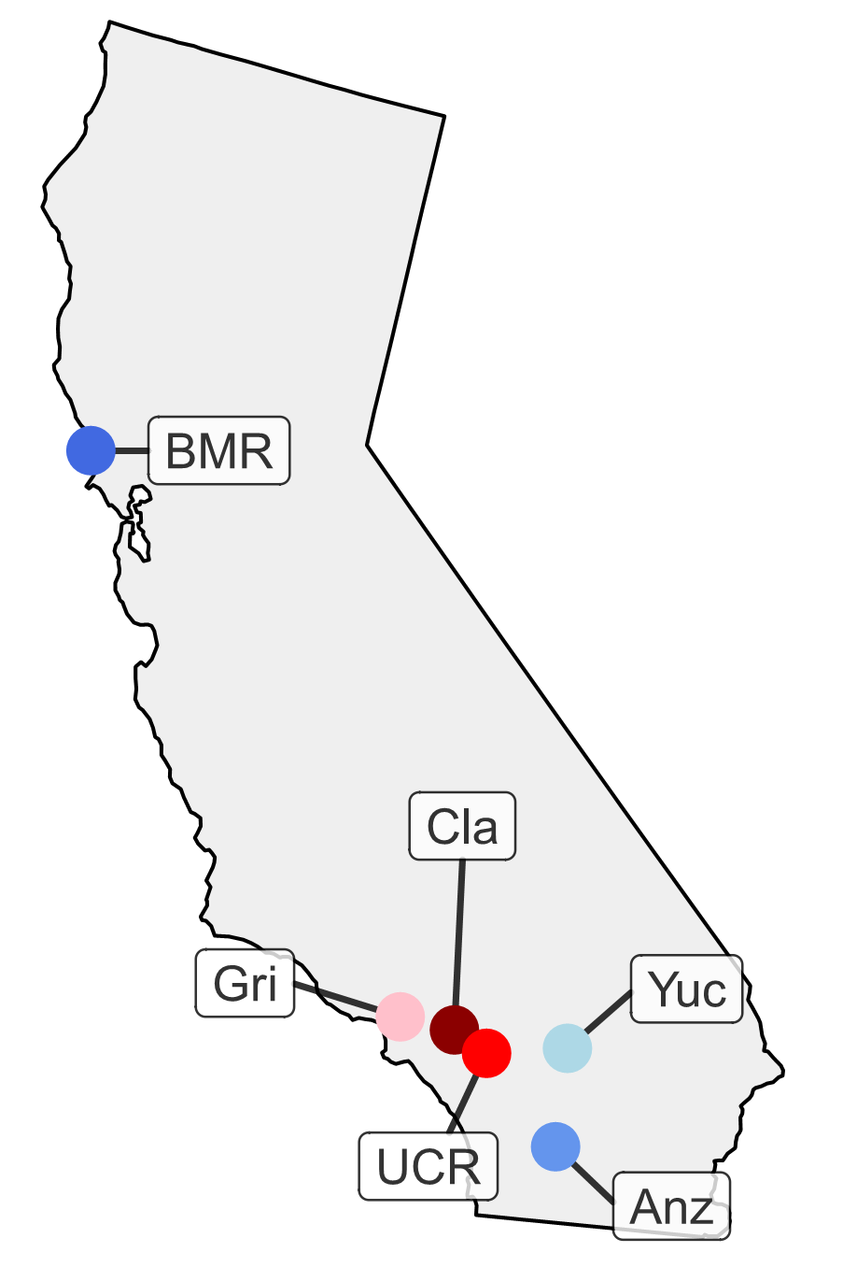

**Figure S1**. Location of six *Acmispon strigosus* field sites in California, USA. Sites are colored by nitrogen regime (i.e., NPC1 values; see Fig. 1), ranging from blue (low nitrogen) to red (high nitrogen).



**Figure S2.** Greenhouse experimental design. We used one live and one sterilized soil inoculum from each of six field sites, for a total of twelve inocula in the greenhouse experiment. Each inoculum was applied to one cluster of five plants within each of ten experimental blocks. We randomly assigned live inocula to non-adjacent clusters and randomly assigned sterilized inocula to the remaining clusters, generating a checkerboard pattern of live and sterilized inocula to reduce the chance of cross-contamination among live inocula. Within each inoculum cluster, three plants belonged to the Common Host Experiment (comprising one plant each of *A. strigosus* Cla12.04, *A. strigosus* Anz13.04, and *A. heermannii*), and two plants belonged to the Sympatric Host Experiment (i.e., *A. strigosus* sourced from the same field site as the inoculum). There were a total of 60 plants per block and 600 plants total in the experiment (actually 567 plants due to early seedling mortality), with 360 plants analyzed as the Universal Host Experiment and 240 plants analyzed as the Sympatric Host Experiment.

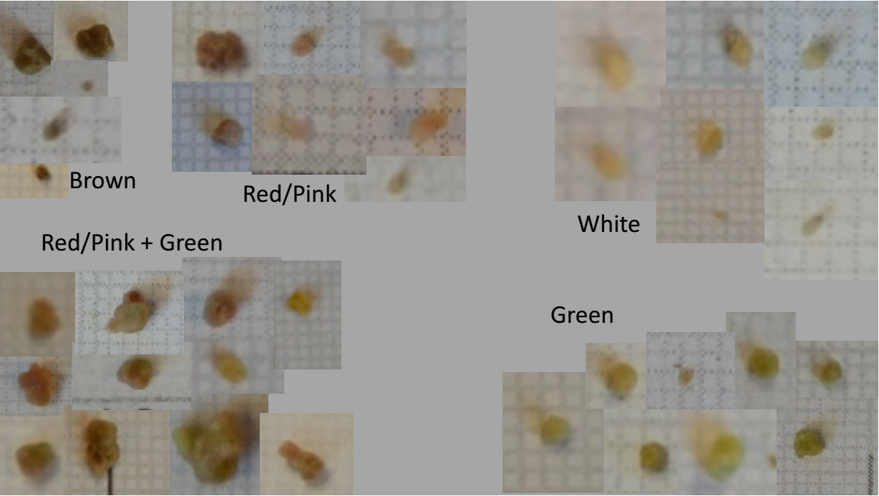

**Figure S3**. Scoring guide used by three independent observers to assess *Acmispon strigosus* nodule color from photographs taken at the time of plant harvest. Nodules scored as “Red/Pink” were used to calculate red nodule frequency for each plant.

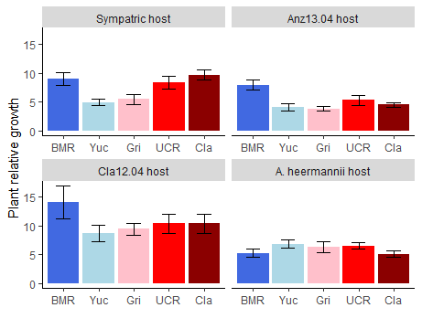

**Figure S4.** Variation in plant relative growth for four types of *Acmispon* plant hosts (sympatric *A. strigosus*, *A. strigosus* Anz13.04, *A. strigosus* Cla12.04, and *A. heermannii*) in response to inoculation with five soils (BMR, Yuc, Gri, UCR, Cla). Soils are arranged in order of increasing soil nitrogen (i.e., NPC1 values; see Fig. 1). Bars represent +/- 1 SE.

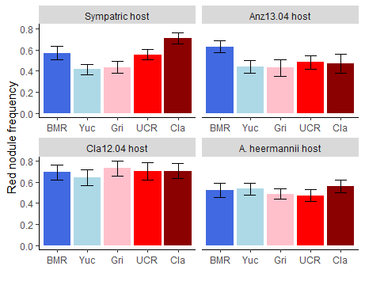

**Figure S5.** Variation in red nodule frequency for four types of *Acmispon* plant hosts (sympatric *A. strigosus*, *A. strigosus* Anz13.04, *A. strigosus* Cla12.04, and *A. heermannii*) in response to inoculation with five soils (BMR, Yuc, Gri, UCR, Cla). Soils are arranged in order of increasing soil nitrogen (i.e., NPC1 values; see Fig. 1). Bars represent +/- 1 SE.

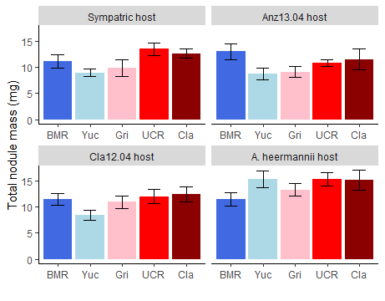

**Figure S6.** Variation in total nodule mass for four types of *Acmispon* plant hosts (sympatric *A. strigosus*, *A. strigosus* Anz13.04, *A. strigosus* Cla12.04, and *A. heermannii*) in response to inoculation with five soils (BMR, Yuc, Gri, UCR, Cla). Soils are arranged in order of increasing soil nitrogen (i.e., NPC1 values; see Fig. 1). Bars represent +/- 1 SE.

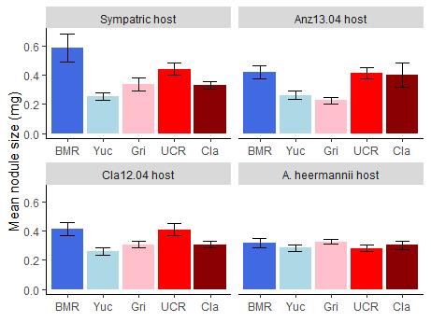

**Figure S7.** Variation in mean nodule size for four types of *Acmispon* plant hosts (sympatric *A. strigosus*, *A. strigosus* Anz13.04, *A. strigosus* Cla12.04, and *A. heermannii*) in response to inoculation with five soils (BMR, Yuc, Gri, UCR, Cla). Soils are arranged in order of increasing soil nitrogen (i.e., NPC1 values; see Fig. 1). Bars represent +/- 1 SE.

**Table S1.** Soil collection information and *Acmispon strigosus* plant lines used in this study.

|  |  |  |  |  |  |  |
| --- | --- | --- | --- | --- | --- | --- |
| **Field site** | **Soil collection date, time** | **Soil collection coordinates** | **Plant lines, experimental names** | **Plant lines, formal names** | ***nrITS* Genbank accession** | ***CNGC5* Genbank accession** |
| BMR | 1 Mar 2015, 0830 h | N 38.3193, W 123.06368 | BMR01.03 | AcS074.BMR.u01.g2.r01_03 | MH201354 | MH223487 |
| BMR07.03 | AcS004.BMR.u01.g2.r01_03 | KX449155 | KX449166 |
| UCR | 2 Mar 2015, 1630 h | N 33.96591, W 117.32271 | UCR02.07 | AcS027.UCR.u01.g1.r10 | MH201360 | MH223492 |
| UCR09.05 | AcS131.UCR.u01.g1.r05 | MH201361 | MH223493 |
| Cla | 2 Mar 2015, 0930 h | N 34.110555, W 117.708798 | Cla10.01 | AcS047.Cla.m01.g2.r07_01 | KX449157 | KX449168 |
| Cla01.04 | AcS049.Cla.m01.g1.r04 | MH201356 | MH223488 |
| Cla12.04 | AcS047.Cla.m01.g2.r09_04 | MH201358 | MH223489 |
| Anz | 27 Feb 2015, 1130 h | N 33.2713, W 116.4194 | Anz11.01 | AcS040.Anz.m01.g2.r06_01 | KX449153 | KX449164 |
| Anz10.01 | AcS039.Anz.m01.g2.r03_01 | MH201351 | MH223485 |
| Anz13.04 | AcS038.Anz.m01.g1.r11 | MH201353 | MH223486 |
| Gri | 2 Mar 2015, 1100 h | N 34.12197, W 118.309 | Gri01.01 | AcS075.Gri.u01.g1.r01 | MH220053 | MH223490 |
| Gri01.13 | AcS075.Gri.u01.g1.r13 | MH220054 | MH223491 |
| Yuc | 27 Feb 2015, 1500 h | N 34.15315, W 116.47511 | Yuc02.07 | AcS052.Yuc.m01.g2.r01_07 | KX449161 | KX449172 |
| Yuc02.01 | AcS052.Yuc.m01.g2.r01_01 | KX449161 | KX449172 |

**Table S2:** Likelihood ratio test χ2 statistics for fixed effects in GLMMs modeling traits of *Acmispon strigosus* inoculated with sympatric soils in the Sympatric Host Experiment. P = PC2 for non-nitrogen soil traits. I = inoculum type (live vs. sterilized). For log(Total plant mass) and Root:shoot ratio, n = 187 plants. For other responses, n = 93-94 plants. * *P* < 0.05, ** *P* < 0.001, *** *P* < 0.0001, † *P* < 0.1.

|  |  |  |  |  |
| --- | --- | --- | --- | --- |
| **Model, Response** | | **Model terms** | | |
| P  df = 1 | I  df = 1 | P:I  df = 1 |
| *NonNitrogenPC2 models* | |  |  |  |
|  | Log(Total plant mass) | 0.007 | 248.09*** | 5.56* |
|  | Root:shoot ratio | 0.68 | 187.33*** | 1.72 |
|  | Plant relative growth | 1.89 |  |  |
|  | Red nodule frequency | 5.96* |  |  |
|  | Total nodule mass | 3.25† |  |  |
|  | Total nodule count | 7.85* |  |  |
|  | Mean nodule size | 0.85 |  |  |

**Table S3:** Likelihood ratio test χ2 statistics for fixed effects in GLMMs modeling traits of three *Acmispon* plant hosts inoculated with five soils in the Common Host Experiment. P = PC2 for non-nitrogen soil traits. I = inoculum type (live vs. sterilized). H = host line (*A. strigosus* Anz13.04, *A. strigosus* Cla12.04, or *A. heermannii*). For log(Total plant mass) and Root:shoot ratio, n = 290 plants. For other responses, n = 149-150 plants. * *P* < 0.05, ** *P* < 0.001, *** *P* < 0.0001, † *P* < 0.1.

|  |  |  |  |  |  |  |  |  |
| --- | --- | --- | --- | --- | --- | --- | --- | --- |
| **Model, Response** | | **Model terms** | | | | | | |
| P  df = 1 | I  df = 1 | H  df = 2 | P:I  df = 1 | P:H  df =2 | I:H  df =2 | P:I:H  df = 2 |
| *NonNitrogenPC2 models* | |  |  |  |  |  |  |  |
|  | log(Total plant mass) | 1.87 | 571.53*** | 182.11*** | 0.91 | 2.88 | 55.54*** | 0.16 |
|  | Root:shoot ratio | 5.47* | 363.94*** | 100.33*** | 1.03 | 1.64 | 24.97*** | 7.08* |
|  | Plant relative growth | 1.41 |  | 50.51*** |  | 0.14 |  |  |
|  | Red nodule frequency | 0.014 |  | 45.44*** |  | 1.38 |  |  |
|  | Total nodule mass | 4.28* |  | 20.17*** |  | 1.09 |  |  |
|  | Total nodule count | 2.40 |  | 33.62*** |  | 5.84† |  |  |
|  | Mean nodule size | 0.64 |  | 3.32 |  | 4.47 |  |  |